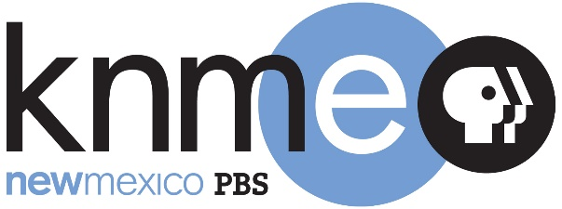

Board of Directors Executive Session
10:00am - Monday, August 23, 2021

Zoom meeting
Please contact Franz Joachim to schedule public comment.
fjoachim@nmpbs.org

Dr. Joseph Escobedo, Chair

A G E N D A

- Bring public meeting to order.
- Approve agenda.
- Approve minutes from August 4, 2021.
- The KNME Board meeting in executive session on August 4, 2021, for the purpose of discussing the purchase and acquisition of real property. The matters discussed in the executive session are limited only to those specified.
- Exit closed Executive Session. The KNME Board met in executive session on August 23, 2021, for the purpose of discussing the purchase and acquisition of real property. The matters discussed in the executive session were limited only to those specified.
- Adjournment

